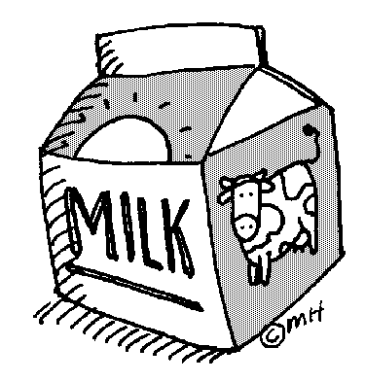
Milk Lunch Order Form
St. Veronica School offers lunch milk (white or chocolate) for purchase for Pre K – 8th grade students.
Milk may be purchased for the entire year.
White milk is .43 cents per day
Chocolate milk is .48 cents per day

If you would like to purchase lunch milk for your child please complete and return this form by Friday, August 31st. Lunch milk will start on Tuesday, September 4, 2018.

$69.66 – full year lunch WHITE MILK per child

$77.76 – full year lunch CHOCOLATE MILK per child

FAMILY LAST NAME:_________________________________________________________________________

Student first name:_________________________________Teacher:__________________Chocolate or White
Student first name:_________________________________Teacher:__________________Chocolate or White
Student first name:_________________________________Teacher:__________________Chocolate or White
Student first name:_________________________________Teacher:__________________Chocolate or White

__________Please charge my FACTS account $_________________ for lunch milk for each child listed above. (Payment total will be divided by 3 and billed September 7th, December 7th and March 15th )

__________Enclosed please find my check for $_______________made out to St. Veronica School for lunch milk for each child listed above.
- Refunds cannot be given for missed school days due to weather or illness.

