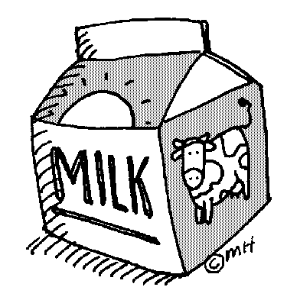
Snack Milk Order Form
St. Veronica School offers snack milk (white or chocolate) for purchase for Pre K and Kindergarten students.
Milk may be purchased each quarter or for the entire year.
White milk is .43 cents per day
Chocolate milk is .48 cents per day

If you would like to purchase snack milk for your child please complete and return this form by Friday, August 31st. Snack milk will start on Tuesday, September 4, 2017.

$74.39 – full year white lunch milk per child
$83.04 – full year chocolate lunch milk per child

FAMILY LAST NAME:_________________________________________________________________________

Student first name:_________________________________Teacher:__________________Chocolate or White
Student first name:_________________________________Teacher:__________________Chocolate or White
Student first name:_________________________________Teacher:__________________Chocolate or White
Student first name:_________________________________Teacher:__________________Chocolate or White

__________Please charge my FACTS account $_________________ for snack milk for each child listed above. (Payment total will be divided by 3 and billed on September 7th, November 7th and March 15th)
__________Enclosed please find my check for $_______________made out to St. Veronica School for snack milk for each child listed above.

- We are not able to provide milk refunds for missed days of school.

